# CS 255 System Design Document

Evan Arthur

## UML Diagrams

### UML Use Case Diagram

### 

### UML Activity Diagrams

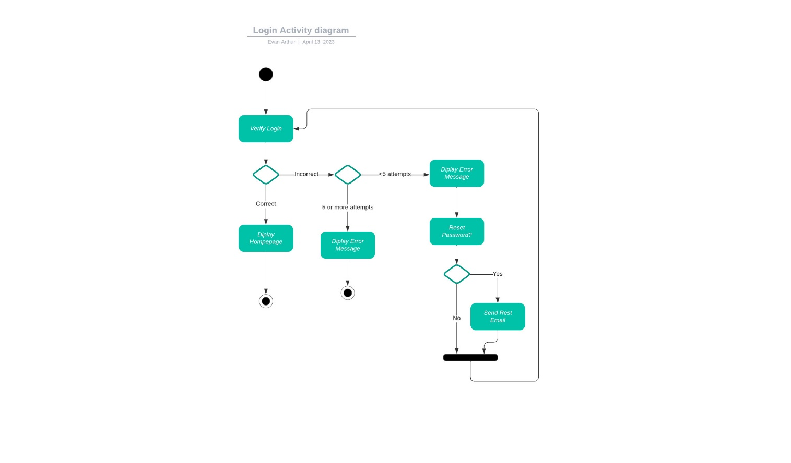

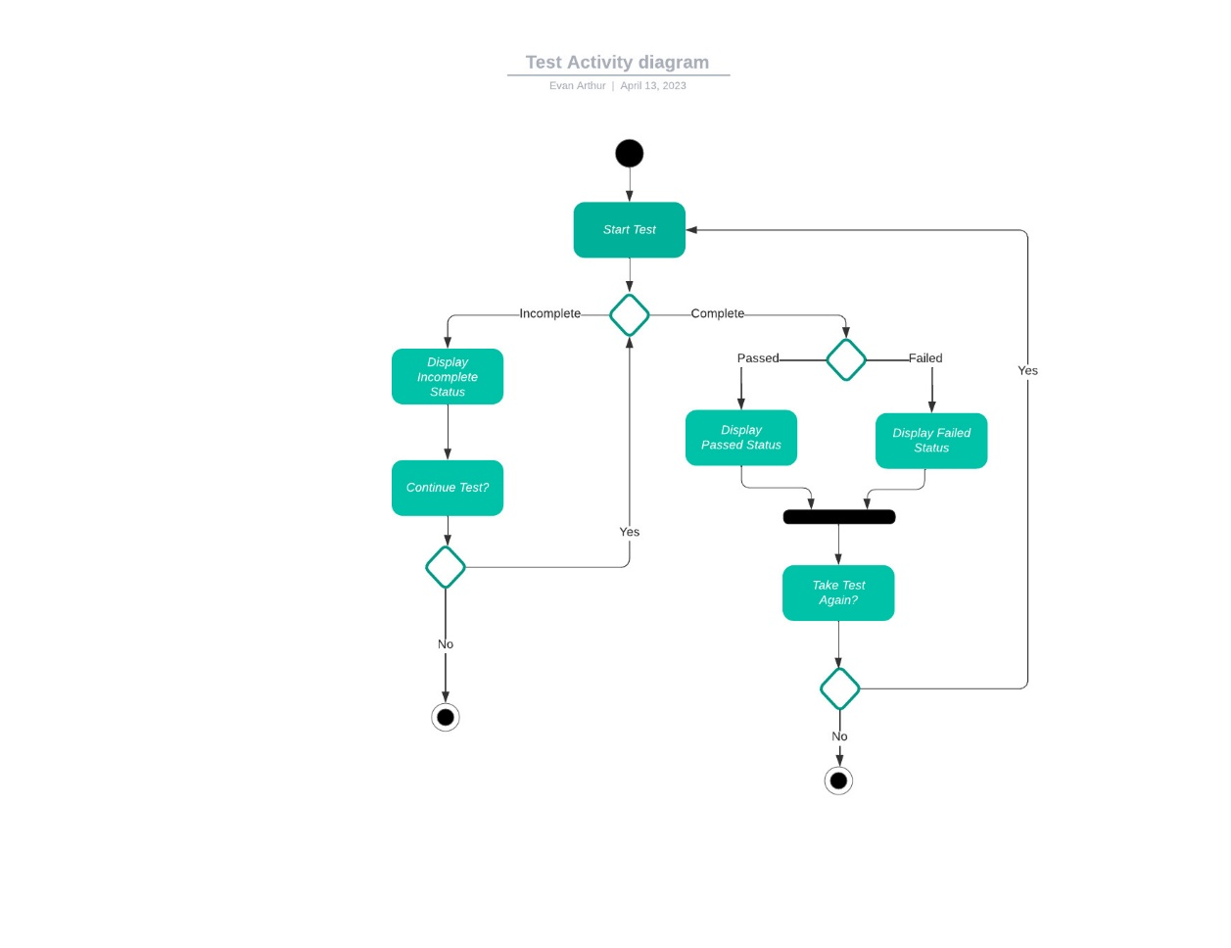

### UML Sequence Diagram

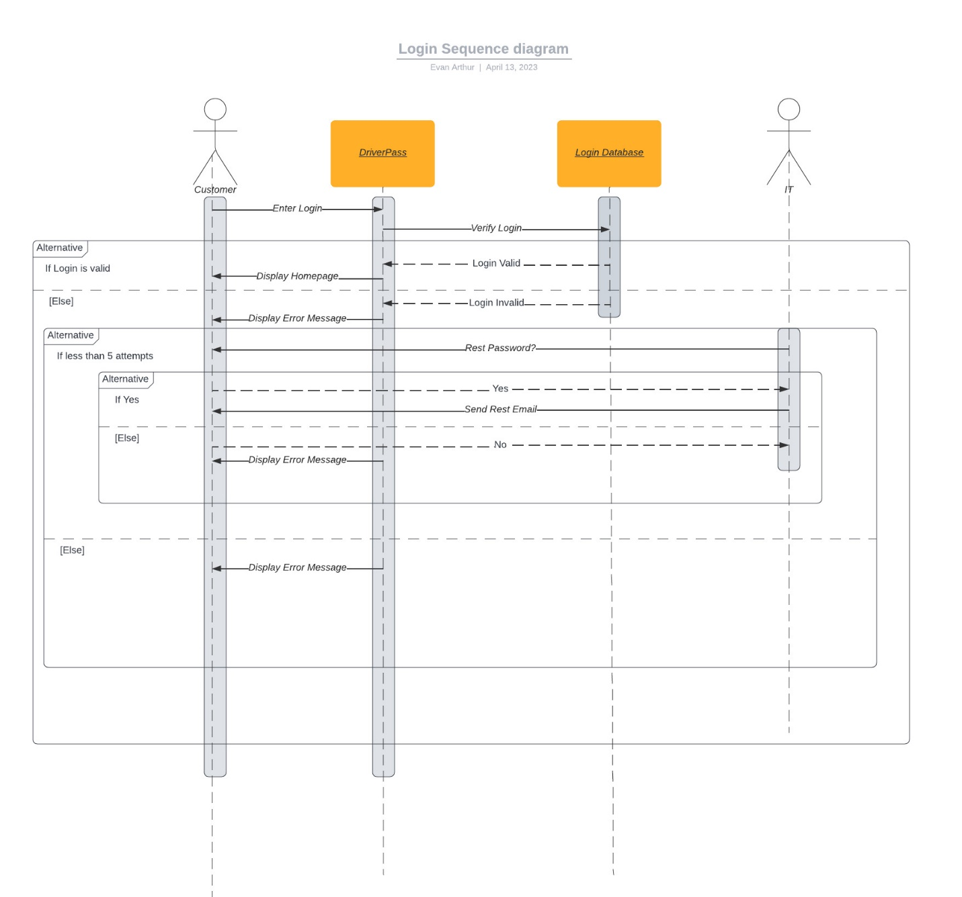

### UML Class Diagram

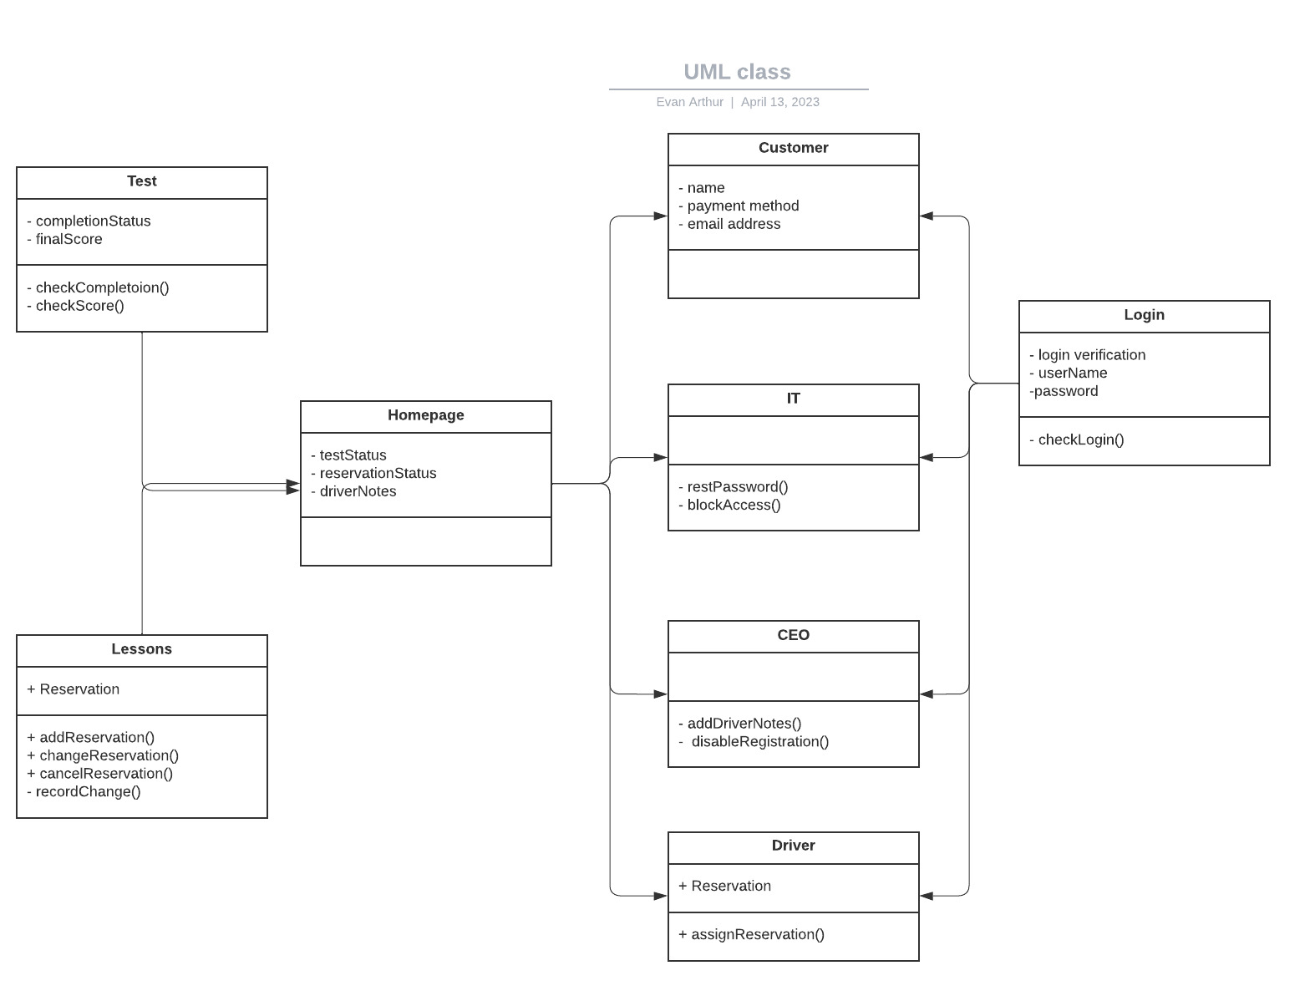

## Technical Requirements

* Internet Access
  + As the system is intended to be a cloud-based system, internet access is key. The speed, and graphics being at a certain level are not necessary, but the experience will be better at higher levels. This is speaking for the customer side. The computers on the business will be required to maintain consistent speeds of at least 100 mb download. This will be fast enough to avoid disatisfaction for the customers who make reservations on the phone or in person. Any basic graphics card in modern hardware will be satisfactory for the requirements of the system.
* Newer operating systems
  + The system will work across different operating systems, but some features will not function on outdated systems. It is not presently clear how updated the operating system needs to be for each but for Windows systems it would be safe to assume Windows 10 and newer will be neccassary. As Windows 10 was released in 2015, any operating system updated to at least 2015 standards should be satisfactory.
* Proximity To Office
  + As the system includes in-person driving lessons it is important that the reservation being made are within a reasonable distance from the office. A reservation made on the other side of the country would be unfeasable. A 50-mile radius is a good place to start. This can be adjusted as needed.
* Email Address
  + In order to reset the passwords for customers or employees the IT department needs an email address. To make it most official it should be a “website” email address. For example, “itdept@driverpass.com”. If it were to come from a personal email account, it may look like a scam and cause issues.
* Data Base
  + The system holds the records of each customer as well as records all the actions taken in regard to individual reservations. Enough space will need to be available to maintain all the information being documented. The system can be set up to delete certain records after a given amount of time, but it is not currently set up to do so. This would help reduce the increasing storage needs in the future. For example, reservation records may be deleted after one year or customer accounts that have been inactive for one consecutive year may be deleted.